
Himchuli Academy
Madhyapur Thimi - 07, Bhaktapur
Second Terminal Examination – 2081

Subject: Opt. Maths FM: 50
Class: VII Time: 2 hours

Note : Failure in writing proper language, reasoning and lack of diagrams, graphs and units will be strictly considered during the assessment.

Group A [7 x1 = 7]
- State One difference between rational and irrational numbers.
- What is Null Matrix with one example.
- How many quadrants are there? mention them.
- Write the formula to find distance between any two points.
- If hypotenuse(h)=5, Perpendicular(p) = 4 and base(b)=3 then find Sinθ and Cosθ.
- Rotate P (x,y) through 90 in an anti-clockwise direction.
- How many degrees is equal to π radian?

Group B[6 x 2 = 12]

- Rationalize the denominator : 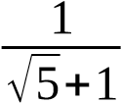
- Find the values of x and y if (5x +1 , 3y – 2) = (11, -5) .

- If P = What type of matrix is P. Also write the Order of Matrix P.
- O(0,0), A(1,1), B(-1,-1) are three points . Prove that OA = OB.
- Prove using p,b,h relation : sinA = √1₋cos² A
- Find the value of p from the given data whose mean is 17.
x | 5 | 10 | 15 | 20 | 25 | 30
f | 2 | 5 | P | 7 | 4 | 2

Group C[4 x 4 = 16]

- Prove that :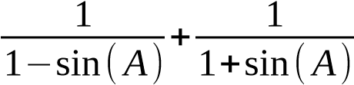=2sec² A
- P(4, 0), Q(5, 2), R(1, 5) are the vertices of ΔPQR. Find the coordinates of its image under the rotation through 180 about origin. Present the object and image in the same graph
- 5, a-2, a+1 and 12 are in ascending order. If the median of the data is 9. find the value of a.
- if , find the values of a,b,c and d

Group D[3 x 5 = 15]
- Find the pre-image of a function f(x) = 2x+1. If the images are the factors of 4. Also show the Function in Arrow and Table diagram.
- Prove that (1, 1), (-1, -1) and (-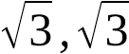) are the vertices of equilateral triangle.
- Prove that : (1 + cotA + tanA)(sinA – cosA) = sinA . tanA – cotA . cosA

